**CSE1002**

**SOFTWARE ENGINEERING FOR WITH DATA ANALYTICS**

**MALLAPU SRINIVAS TEJA SWAROOP**

**192211449**

**1. DRAW A USE CASE DIAGRAM FOR ONLINE VOTING SYSTEM USING CASE TOOLS.**

**AIM:**

To draw a USE CASE diagram for online voting system using CASE tools**.**

**SOFTWARE USED:**

Umbrello.

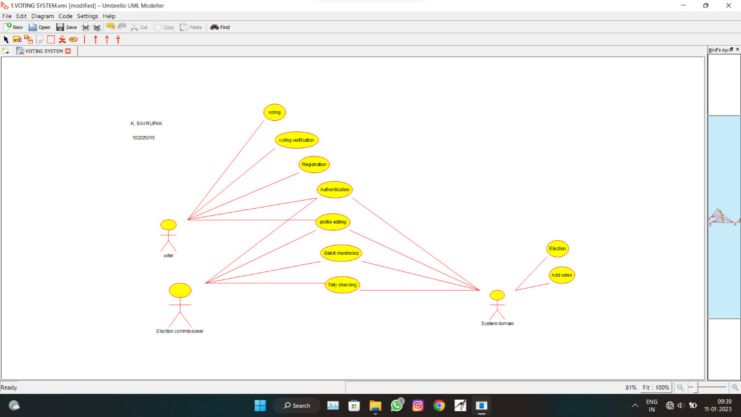

**RESULT:**

USE CASE diagram for online voting system is successfully completed.

**2. DRAW A USE CASE DIAGRAM FOR LIBRARY MANAGEMENT SYSTEM USING CASE TOOLS.**

**AIM:**

To draw a USE CASE diagram for library management system using CASE tools.

**SOFTWARE USED:**

Umbrello.

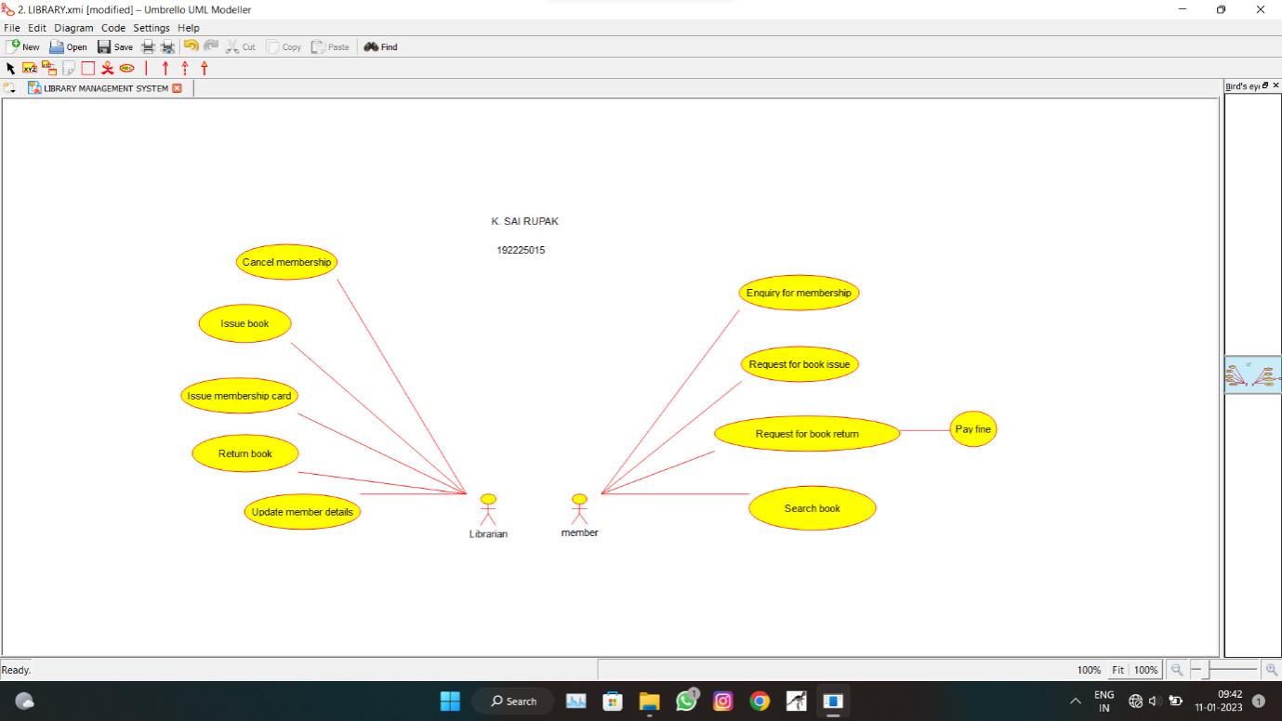

**RESULT:**

USE CASE diagram for library management system is successfully completed**.**

**3.** **DRAW AND VALIDATE THE FLOWCHART TO COMPUTE THE QUOTIENT AND REMAINDER.**

**AIM:**

To draw and validate the flowchart to compute the quotient and remainder.

**SOFTWARE USED:**

Raptor.

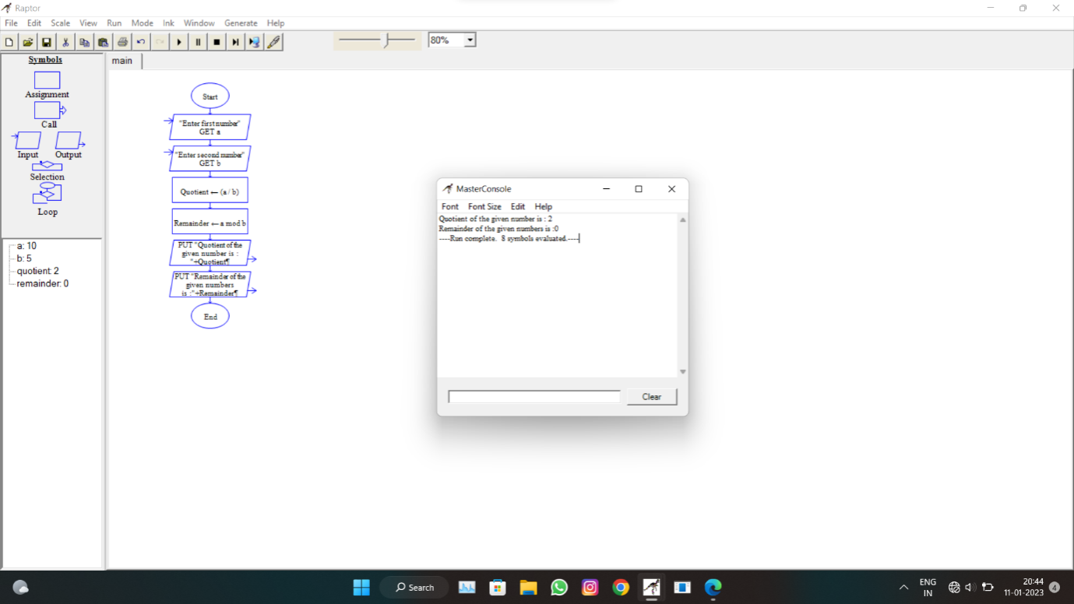

**RESULT:**

The flowchart to compute the quotient and remainder is successfully completed.

**4. DRAW A USE-CASE DIAGRAM FOR ONLINE SHOPPING SYSTEM USING CASE TOOLS.**

**AIM:**

To draw a USE CASE diagram for online shopping system using CASE tools.

**SOFTWARE USED:**

Umbrello.

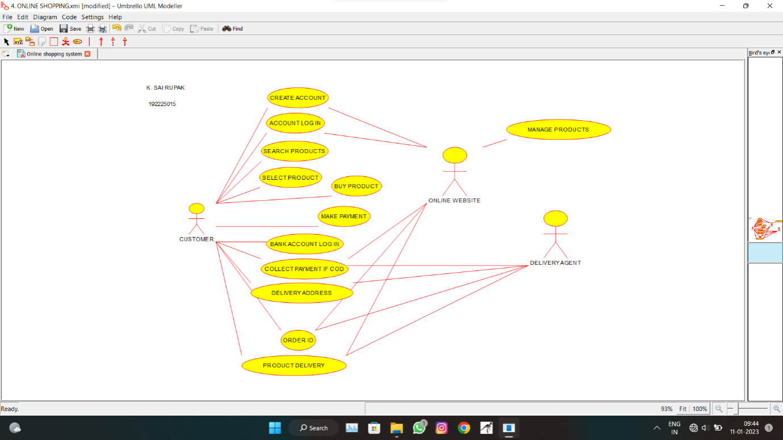

**RESULT:**

USE CASE diagram for online shopping system is successfully completed.

**5. DRAW A USE-CASE DIAGRAM FOR ONLINE RAILWAY RESERVATION SYSTEM USING CASE TOOLS.**

**AIM:**

To draw a USE CASE diagram for online railway reservation system using CASE tools.

**SOFTWARE USED:**

Umbrello.

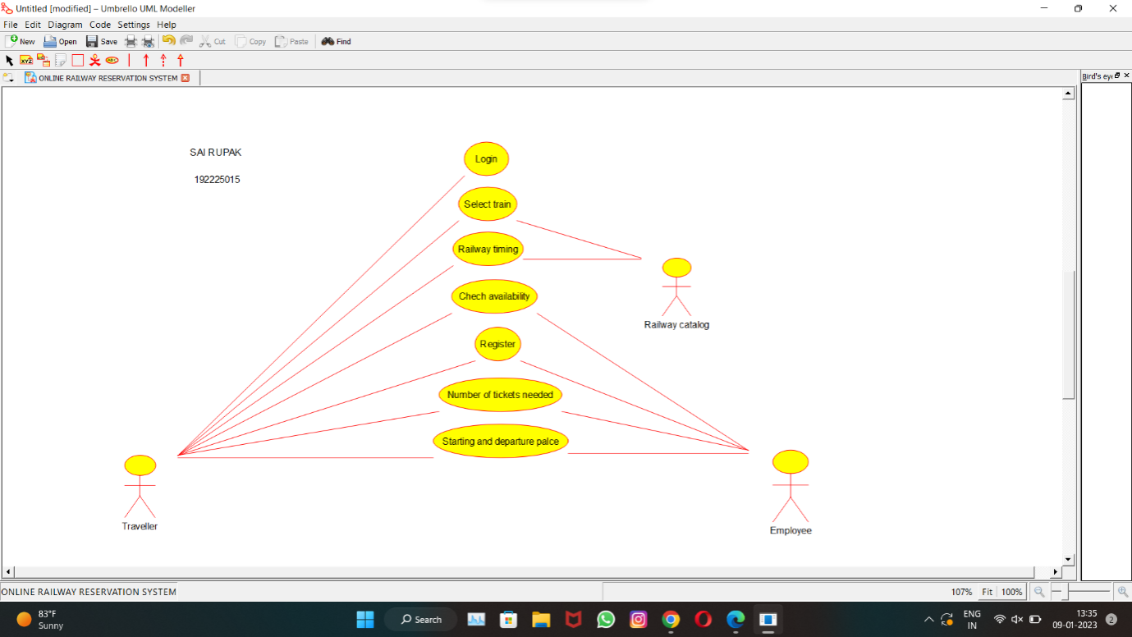

**RESULT:**

USE CASE diagram for online railway reservation systemis successfully completed.

**6. DRAW A USE-CASE DIAGRAM FOR HOSPITAL MANAGEMENT SYSTEM USING CASE TOOLS.**

**AIM:**

To draw a USE CASE diagram for hospital management system using CASE tools.

**SOFTWARE USED:**

Umbrello.

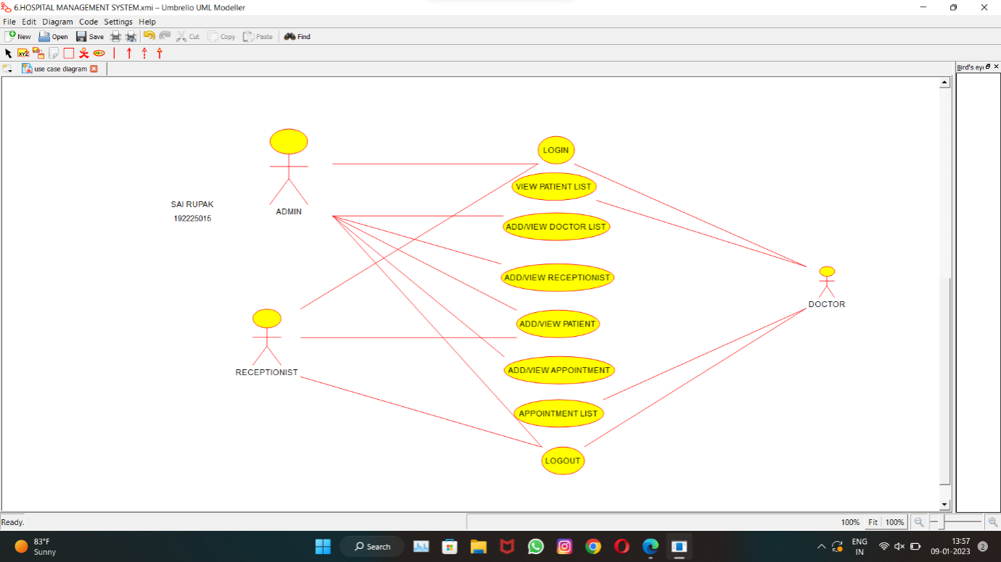

**RESULT:**

USE CASE diagram for hospital management system is successfully completed.

**7. DRAW A USE-CASE DIAGRAM FOR ATM SYSTEM USING CASE TOOLS.**

**AIM:**

To draw a USE CASE diagram for ATM system using CASE tools.

**SOFTWARE USED:**

Umbrello.

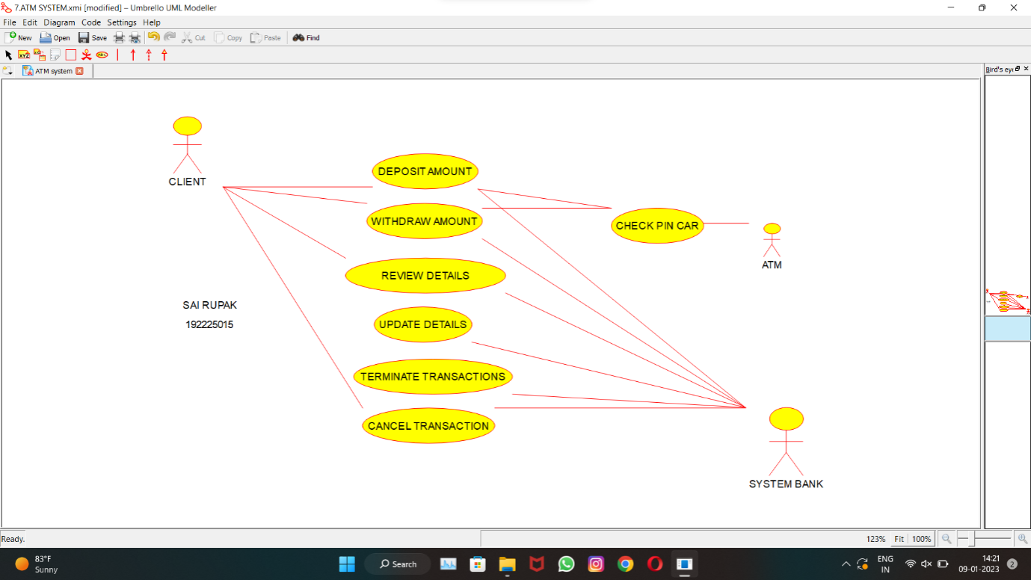

**RESULT:**

USE CASE diagram for ATM system is successfully completed.

**8. DRAW A USE-CASE DIAGRAM FOR ONLINE COLLEGE MANAGEMENT SYSTEM USING CASE TOOLS**

**AIM:**

To draw a USE CASE diagram for online college management system using CASE tools.

**SOFTWARE USED:**

Umbrello.

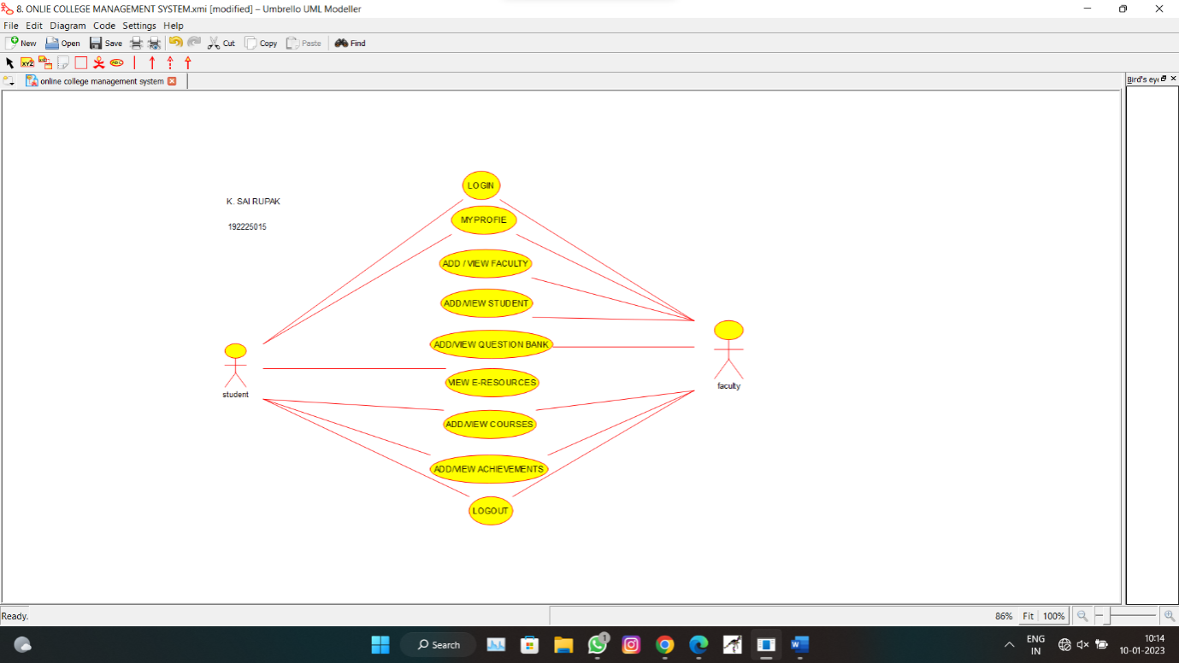

**RESULT:**

USE CASE diagram for online college management is successfully completed.

**9. DRAW A USE-CASE DIAGRAM FOR ONLINE AIRLINE RESERVATION SYSTEM USING CASE TOOLS**

**AIM:**

To draw a USE CASE diagram for online airline reservation system using CASE tools.

**SOFTWARE USED:**

Umbrello.

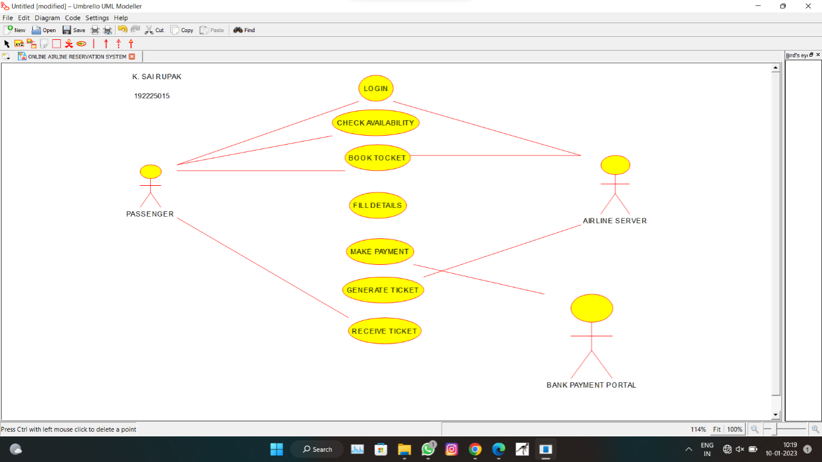

**RESULT:**

USE CASE diagram for online airline reservation system is successfully completed.

**10. DRAW A CLASS DIAGRAM FOR ONLINE AIRLINE RESERVATION SYSTEM USING CASE TOOLS.**

**AIM:**

To draw a class diagram for online airline reservation system using CASE tools.

**SOFTWARE USED:**

Umbrello.

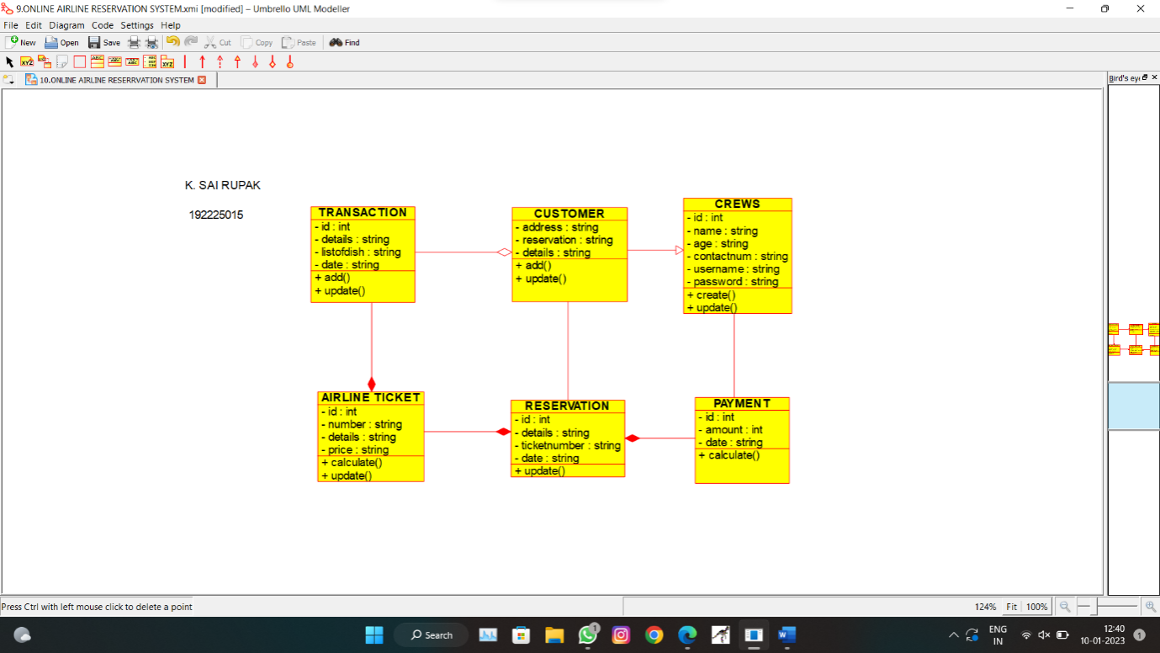

**RESULT:**

Class diagram for online airline reservation system is successfully completed.

**11. DRAW A CLASS DIAGRAM FOR ONLINE VOTING SYSTEM USING CASE TOOLS.**

**AIM:**

To draw a class diagram for online voting system using CASE tools.

**SOFTWARE USED:**

Umbrello.

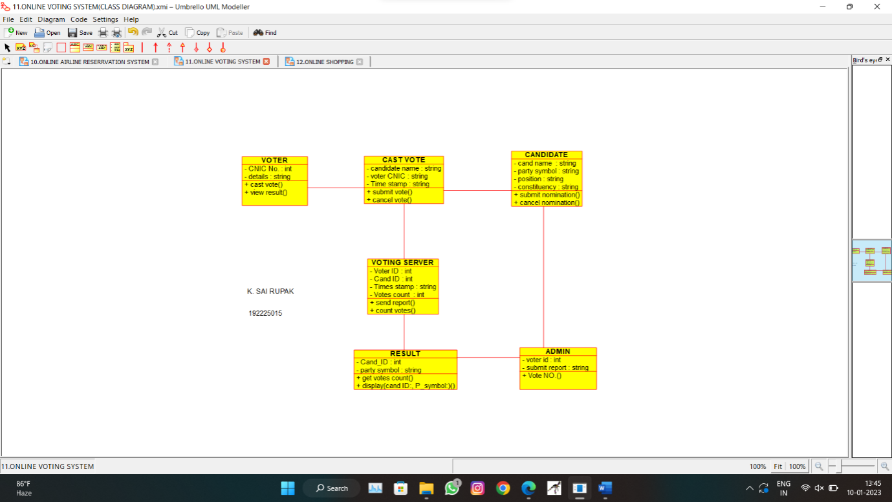

**RESULT:**

Class diagram for online voting system is successfully completed.

**12. DRAW A CLASS DIAGRAM FOR LIBRARY MANAGEMENT SYSTEM USING CASE TOOLS.**

**AIM:**

To draw a class diagram for library management system using CASE tools.

**SOFTWARE USED:**

Umbrello.

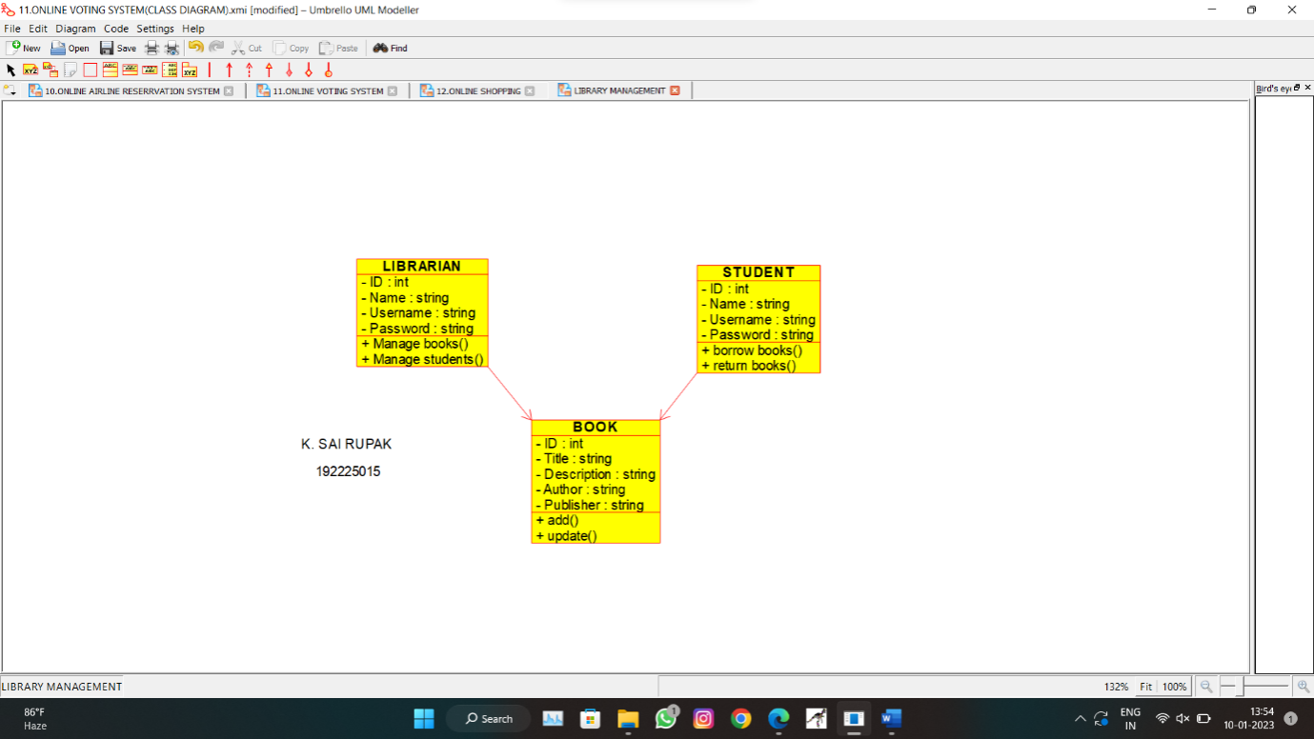

**RESULT:**

Class diagram for library management system is successfully completed.

**13. DRAW A CLASS DIAGRAM FOR ONLINE SHOPPING SYSTEM USING CASE TOOLS.**

**AIM:**

To draw a class diagram for online shopping system using CASE tools.

**SOFTWARE USED:** Umbrello.

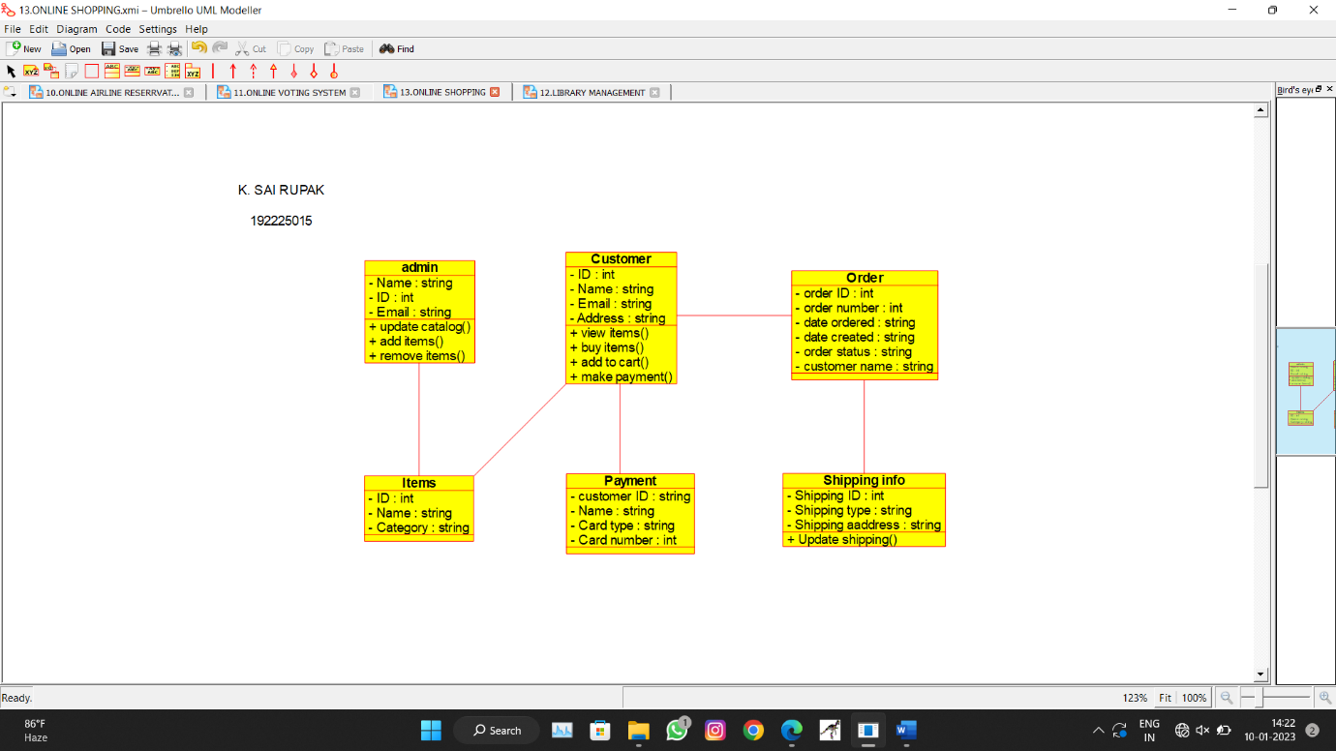

**RESULT:**

Class diagram for online shopping system is successfully completed.

**14. DRAW A CLASS DIAGRAM FOR ONLINE RAILWAY RESERVATION SYSTEM USING CASE TOOLS.**

**AIM:**

To draw a class diagram for online railway reservation system using CASE tools.

**SOFTWARE USED:**

Umbrello.

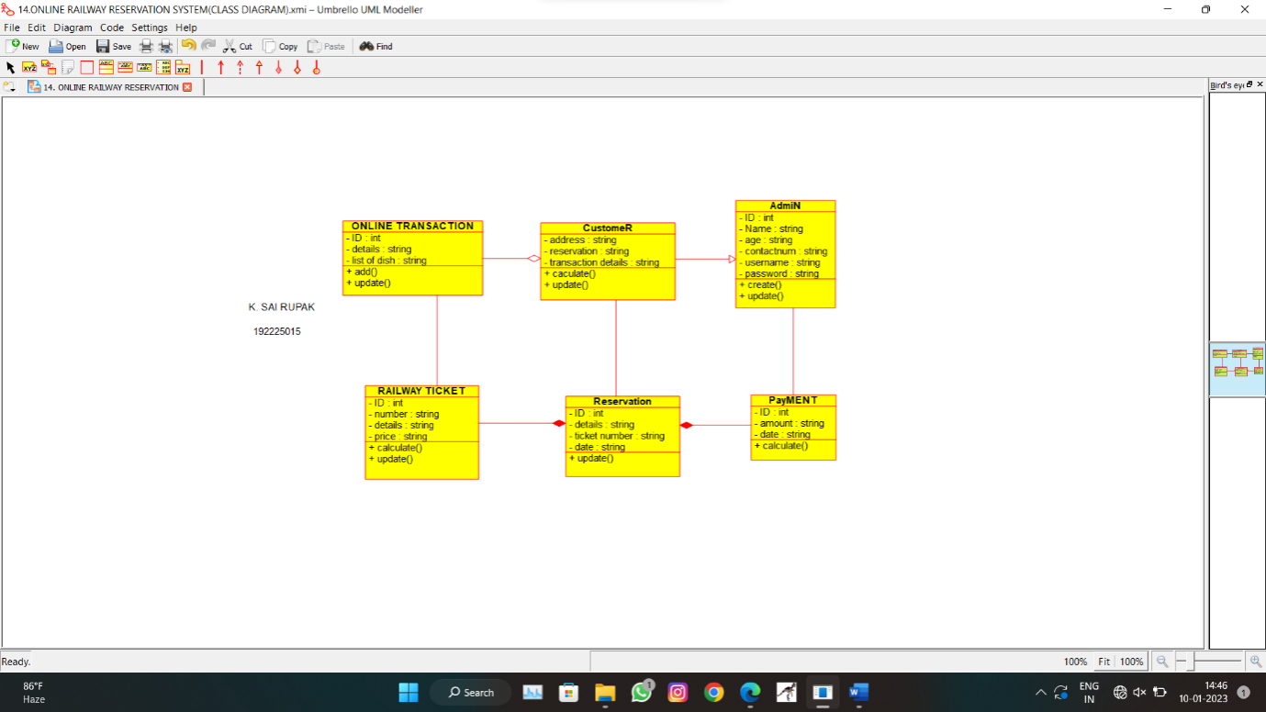

**RESULT:**

Class diagram for online railway reservation system is successfully completed.

**15. DRAW A ACTIVITY DIAGRAM FOR ONLINE VOTING SYSTEM USING CASE TOOLS.**

**AIM:**

To draw a activity diagram for online voting system using CASE tools.

**SOFTWARE USED:**

Umbrello.

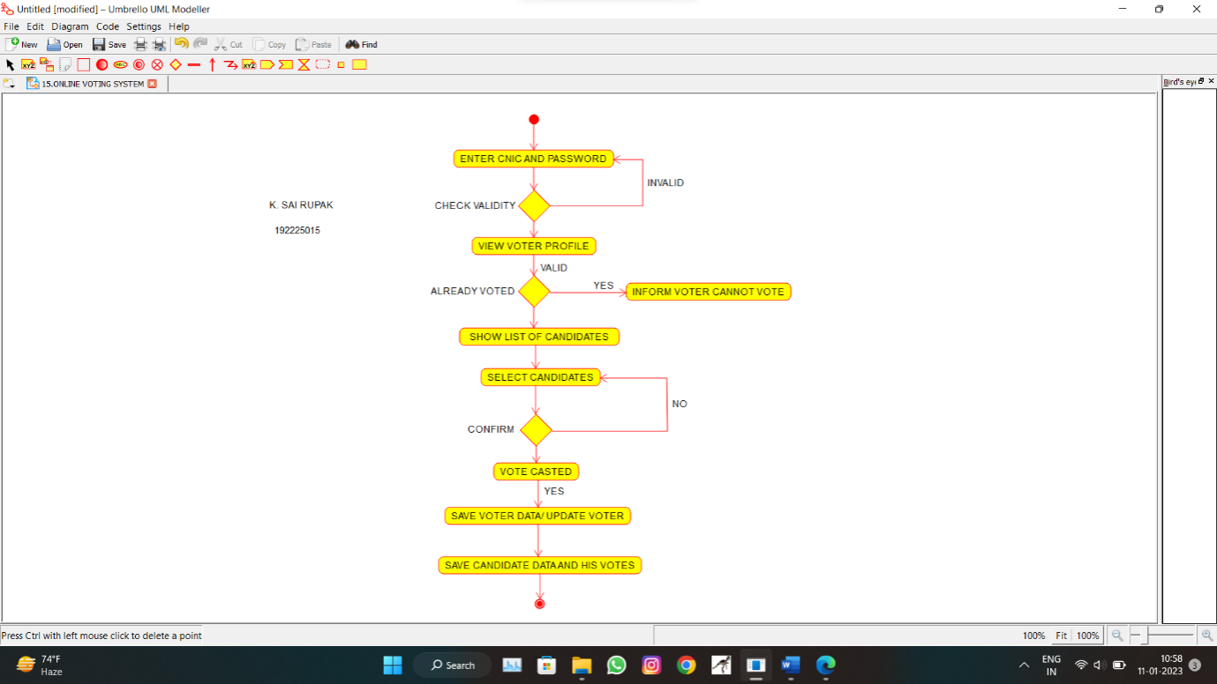

**RESULT:**

Activity diagram for online voting system is successfully completed.

**16. DRAW A ACTIVITY DIAGRAM FOR LIBRARY MANAGEMENT SYSTEM USING CASE TOOLS.**

**AIM:**

To draw a activity diagram for library management system using CASE tools.

**SOFTWARE USED:**

Umbrello.

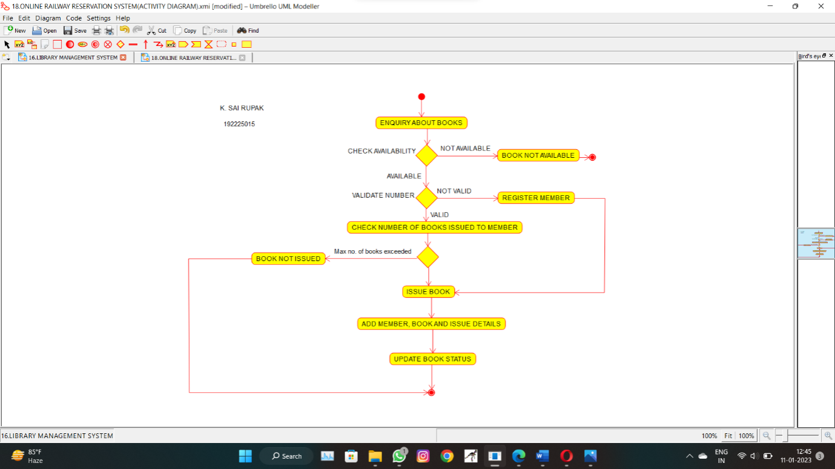

**RESULT:**

Activity diagram for library management system is successfully completed.

**17. DRAW A ACTIVITY DIAGRAM FOR ONLINE SHOPPING SYSTEM USING CASE TOOLS.**

**AIM:**

To draw a activity diagram for online shopping system using CASE tools.

**SOFTWARE USED:**

Umbrello.

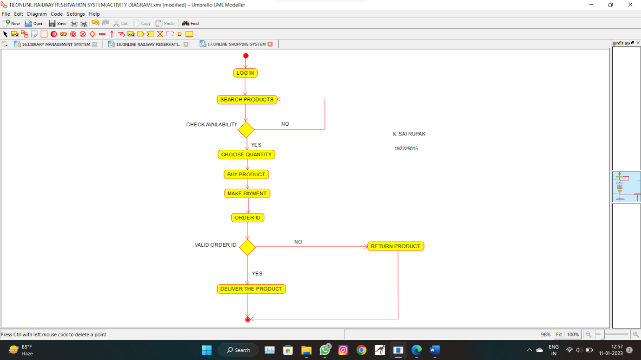

**RESULT:**

Activity diagram for online shopping system is successfully completed.

**18. DRAW A ACTIVITY DIAGRAM FOR ONLINE RAILWAY RESERVATION SYSTEM USING CASE TOOLS.**

**AIM:**

To draw a activity diagram for online railway reservation system using CASE tools.

**SOFTWARE USED:**

Umbrello.

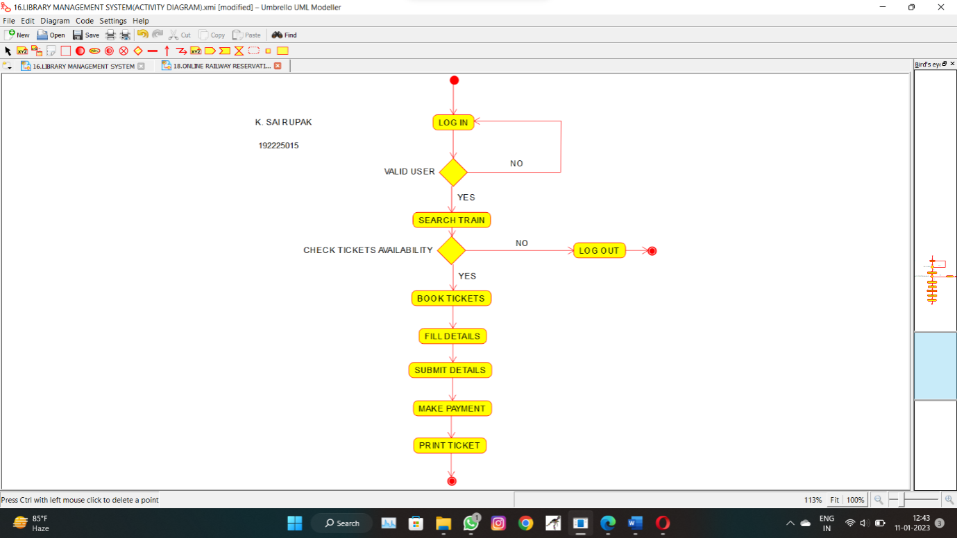

**RESULT:**

Activity diagram for online railway reservation system is successfully completed.

**19. DRAW A ACTIVITY DIAGRAM FOR HOSPITAL MANAGEMENT SYSTEM USING CASE TOOLS.**

**AIM:**

To draw a activity diagram for hospital management system using CASE tools.

**SOFTWARE USED:**

Umbrello.

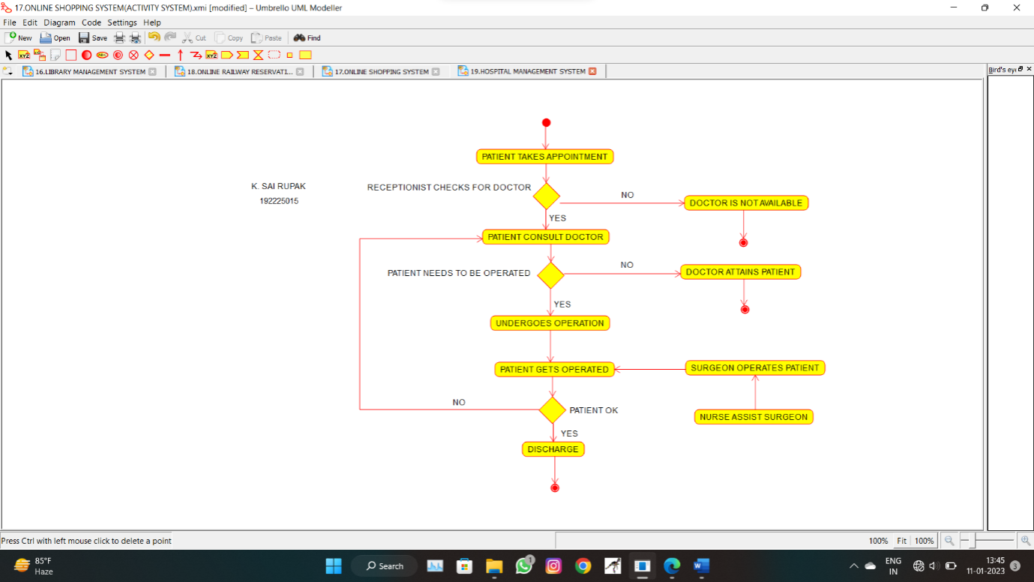

**RESULT:**

Activity diagram for hospital management system is successfully completed.

**20. USING RAPTOR- DRAW THE FLOWCHART TO CHECK WHETHER THE GIVEN NUMBER IS A PALINDROME OR NOT.**

**AIM:**

To draw the flowchart to check whether the given number is a palindrome or not**.**

**SOFTWARE USED:**

Raptor.

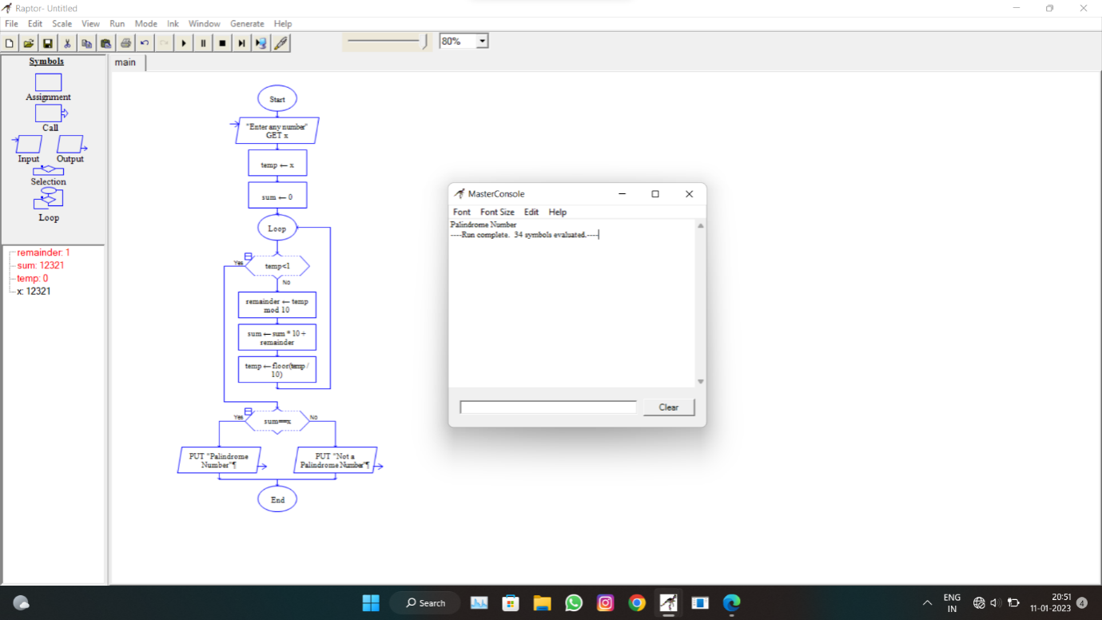

**RESULT:**

The flowchart to check whether the given number is a palindrome or not is successfully completed.

**21. USING RAPTOR- DRAW AND VALIDATE THE FLOWCHART TO CALCULATE FIBONACCI SERIES.**

**AIM:**

To draw and validate the flowchart to calculate Fibonacci series.

**SOFTWARE USED:**

Raptor.

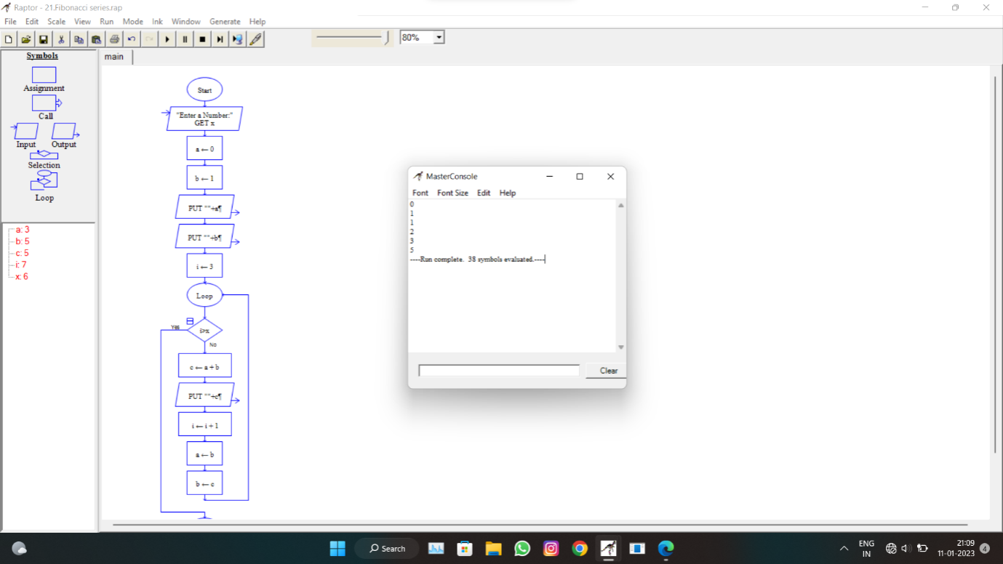

**RESULT:**

The flowchart to calculate Fibonacci series is successfully completed.

**22. USING RAPTOR – DRAW AND VALIDATE THE FLOWCHART TO SWAP TWO CHARACTERS.**

**AIM:**

To draw and validate the flowchart to swap two characters.

**SOFTWARE USED:**

Raptor.

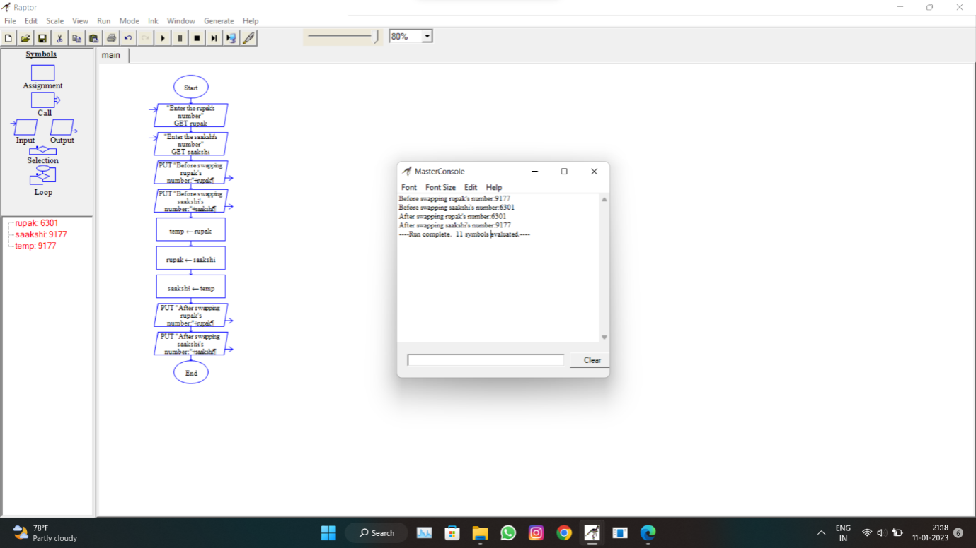

**RESULT:**

The flowchart to swap two characters is successfully completed.

**23. USING RAPTOR – DRAW THE FLOWCHART TO DISPLAY THE LENGTH OF THE STRING.**

**AIM:**

To draw the flowchart to display the length of the string.

**SOFTWARE USED:**

Raptor.

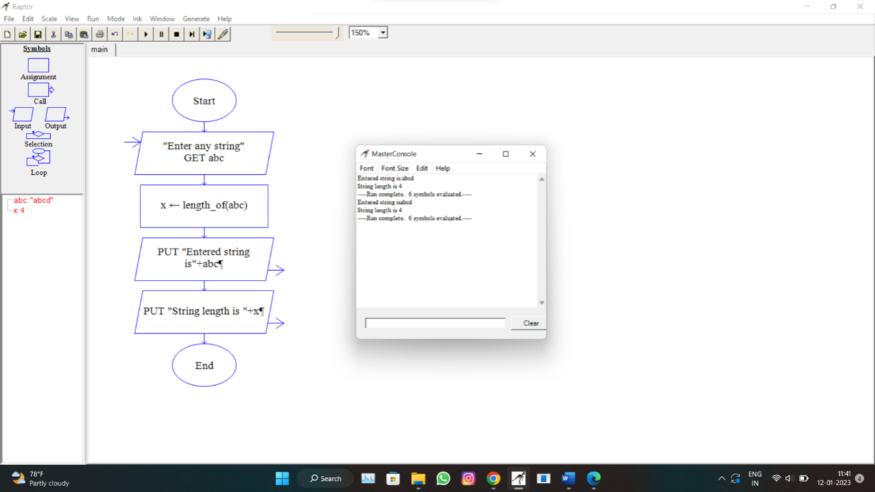

**RESULT:**

The flowchart to display the length of the string is successfully completed.

**24. USING RAPTOR – DRAW THE FLOWCHART TO FIND WHETHER THE GIVEN NUMBER IS PRIME OR NOT.**

**AIM:**

To draw the flowchart to find whether the given number is prime or not.

**SOFTWARE USED:**

Raptor.

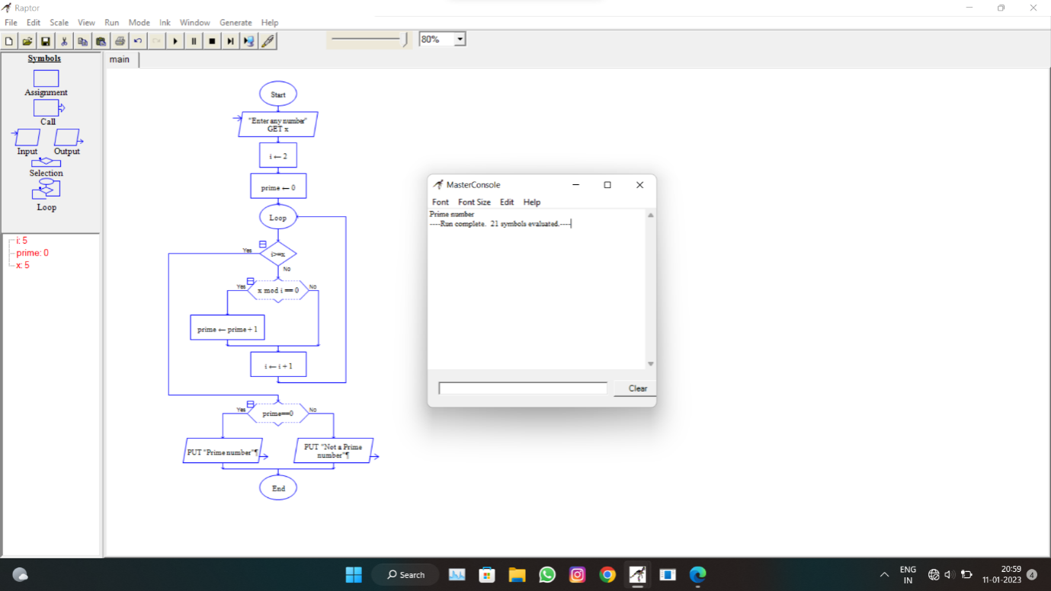

**RESULT:**

The flowchart to find whether the given number is prime or not.

**25. FIND CYCLOMATIC COMPLEXITY FOR A GRAPH HAVING NUMBER OF EDGES AS 12, NUMBER OF NODES AS 13 AND NUMBER OF PREDICATE NODES IN THE FLOW GRAPH AS 5.**

